2 TIER ARCHITECTURE PROJECT

VINEETH KUMAR M

INDEX PAGE
- INTRODUCTION
- ARCHITECTURE
- WORKFLOW
- EXPLANATION
- RESULT

- INTRODUCTION

This project is a cloud-based student form creation developed using AWS services. It follows a multi-tier architecture where frontend, backend, and database are deployed separately.

- ARCHITECTURE:

  - Frontend – ec2 server (ubuntu) using html.
  - Backend – flask api (python)

- WORKFLOW:

  - Create frontend EC2 server
  - Create VPC for EC2
  - Create backend EC2 server
  - Create a mysql DB
  - Install nginx server on frontend
  - Install python on backend

4 – EXPLANATION:

Step-1 Create a VPC
Step-2 Create 2 subnets,
- Create 1 public subnet – frontend.
- Create 1 private subnet – Backend
Step-3 Create Route table,
- Create a Public RT.
- Create a Private RT.
Step-4 Create internet gateway then,
- Attach the IGW to VPC.
- Attach the public subnet to the public Route table.
- Attach the private subnet to the public Route table.
- Edit subnet association explicit connection.
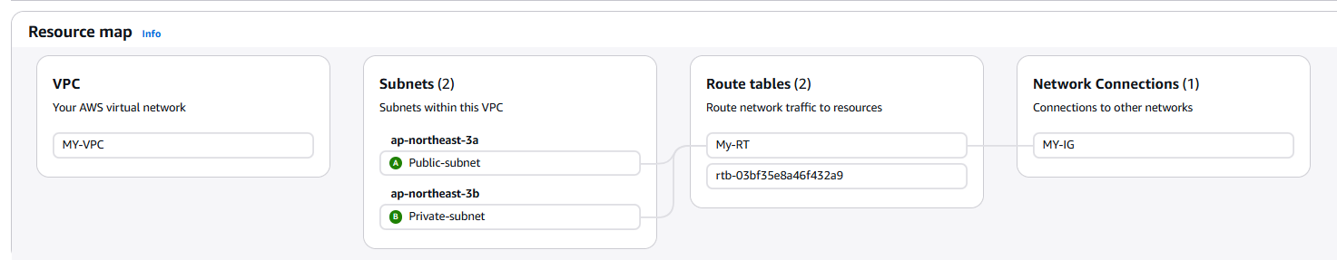

Step -5 Create a EC2 INSTANCE
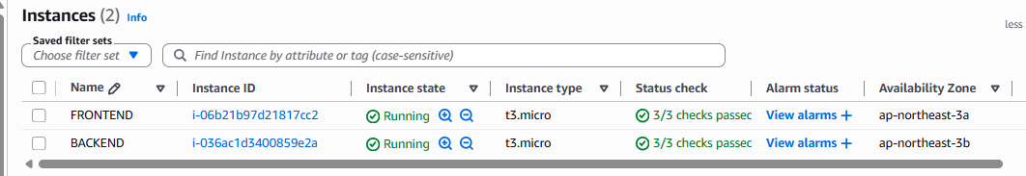
Step-6 Launch front-end EC2 instance
- Frontend – Nginx.
- Operating system: Ubuntu AMI
- Subnet: Public
- Attached the SG group
- Auto assign IP.
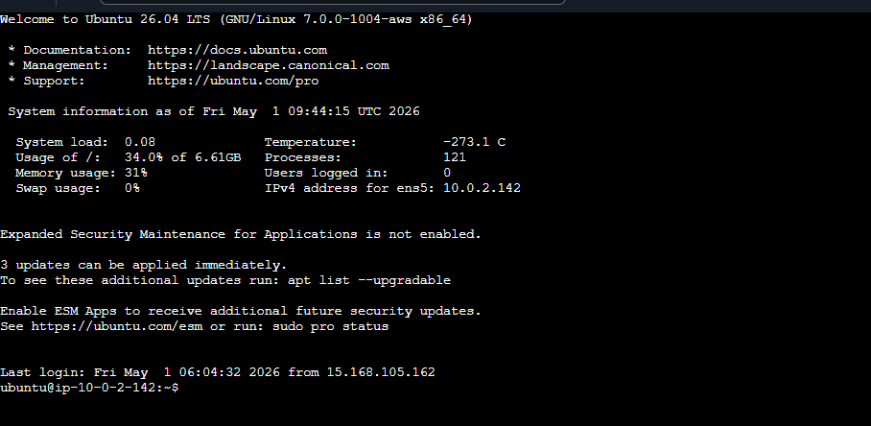
Step-6 Launch Back-end EC2 instance.
- Front end – Flash API
- Operating system: Ubuntu AMI
- Subnet: Private
- Attached the SG group
- Auto assign IP.
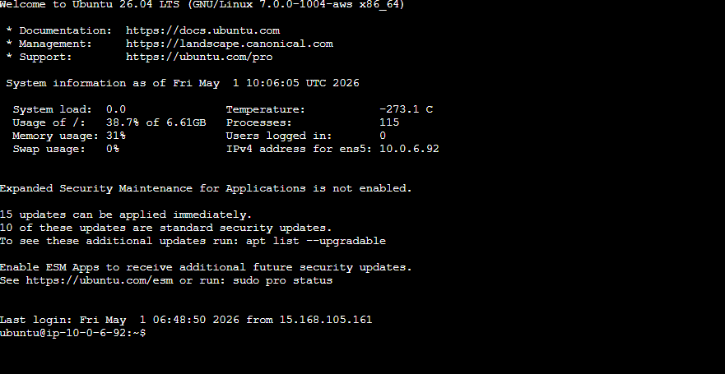
Step-7 Go-to Security group inbound rules
- Allow the ports which you need.
- Allow custom port 5000 (for python)
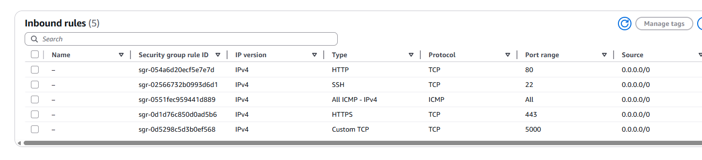
Connect your server and use below some commands to update your kernel and install nginx,

LINUX – OPERATING SYSTEM
- sudo apt update –y
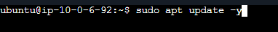
- sudo nano “key pair name” (update your key pair name)
- sudo chmod 400 “key pair name” (change the permission to your key pair)
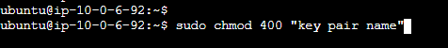
NGINX - SERVER
Install nginx server in frontend by using below commands:
- sudo apt install nginx
- default path (nginx) var/www/html/index.nginx-debian.html
- update your html code in that .html page
- now your front-end is working
Create a connection between FRONT-END TO BACKEND

FRONT-END ============== API ==============BACK-END
BACKEND - SERVER
Connect your server and use below some commands to install nginx and update your kernel,
- sudo apt update –y

- sudo nano “key pair name” (update your key pair name)

- sudo chmod 400 “key pair name” (change the permission to key pair)

You need to install python in you back-end-server by using below commands,
- sudo apt install python3-pip-y
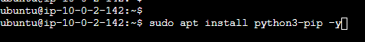
- pip3 install flask flask-cors --break-system-packages
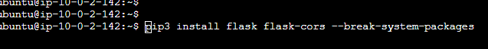
- create app.py (update your flask code)
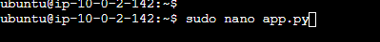
- python3 app.py (now python is running on your server)

Use the below html code in front-end-server
- go to your nginx default path and,
- edit the .html file with below html
<!DOCTYPE html>
<!DOCTYPE html>
<html>
<head>
<title>Student Registration</title>
<style>
body {
font-family: Arial;
background: #f2f2f2;
padding: 30px;
}

.box {
width: 320px;
background: white;
padding: 20px;
border-radius: 10px;
box-shadow: 0 0 10px gray;
}

input, button {
width: 100%;
margin-top: 10px;
padding: 8px;
}

button {
background: blue;
color: white;
border: none;
cursor: pointer;
}

#list {
margin-top: 20px;
padding: 10px;
background: #e6ffe6;
border-radius: 5px;
}
</style>
</head>
<body>

<div class="box">
<h2> Student Form</h2>

<form id="form">
<input type="text" id="name" placeholder="Name" required>
<input type="number" id="age" placeholder="Age" required>
<input type="text" id="course" placeholder="Course" required>

<button type="submit">Submit</button>
</form>

<div id="list"></div>
</div>

<script>
const listDiv = document.getElementById("list");

document.getElementById("form").addEventListener("submit", function(e) {
e.preventDefault();

const data = {
name: document.getElementById("name").value,
age: document.getElementById("age").value,
course: document.getElementById("course").value
};

fetch("http://YOUR_IP_ADDRESS:5000/student", {
method: "POST",
headers: {
"Content-Type": "application/json"
},
body: JSON.stringify(data)
})
.then(res => res.json())
.then(response => {
listDiv.innerHTML = "<h3>Student List:</h3>";

response.students.forEach((s, index) => {
listDiv.innerHTML += `
<p>${index + 1}. ${s.name} - Age: ${s.age} - Course: ${s.course}</p>
`;
});
})
.catch(error => {
listDiv.innerHTML = "❌ Server Error!";
console.error(error);
});
});
</script>

</body>
</html>

- Try your Frontend ip address in your chrome.
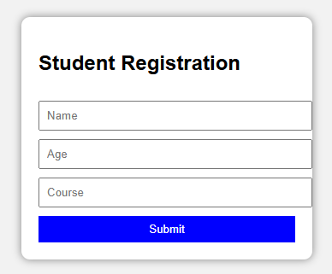
- Go to backend server and update your app.py by using below code which you created,
Update your app.py (flask code) by below code: Just copy paste
from flask import Flask, request, jsonify
from flask_cors import CORS

app = Flask(__name__)
CORS(app)

students = [] # store all students

@app.route('/student', methods=['POST'])
def add_student():
data = request.get_json()

student = {
"name": data.get('name'),
"age": data.get('age'),
"course": data.get('course')
}

students.append(student)

return jsonify({
"message": "Student added successfully",
"students": students
})

if __name__ == '__main__':
app.run(host='0.0.0.0', port=5000, debug=True)

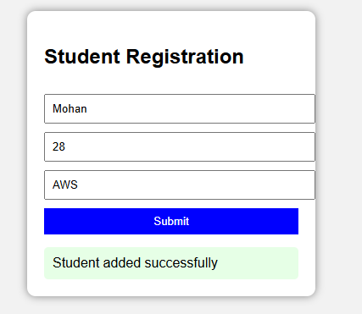

THANK YOU

